# CS 255 System Design Document Template

**Jiwon Lee**

## UML Diagrams

### UML Use Case Diagram

### UML Activity Diagrams

### UML Sequence Diagram: Schedule Driving lesson

### UML Class Diagram

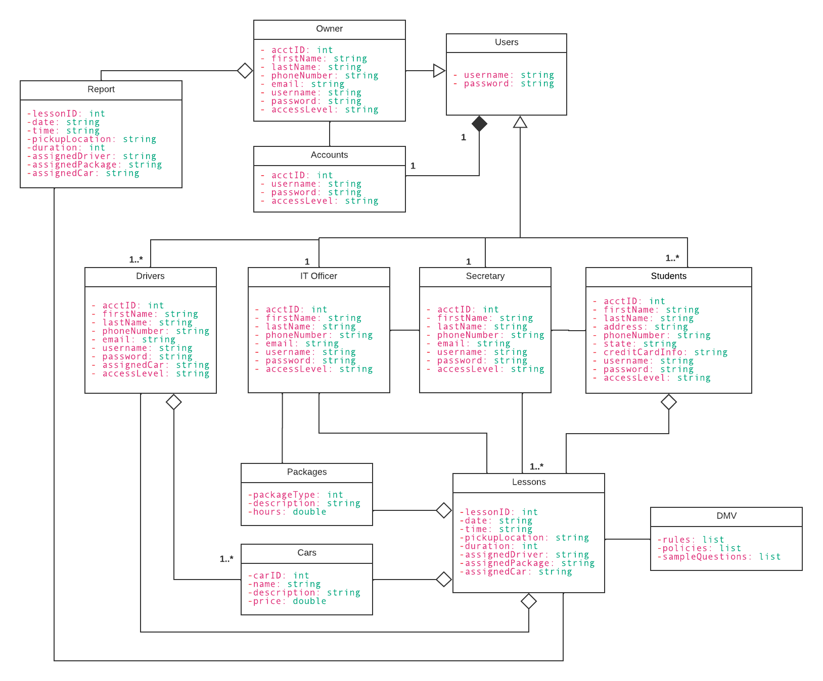

## Technical Requirements

*Hardware:*

* *A web server to host the website and handle online reservations and payments*
* *Desktop computers for the secretary and IT officers to access the system and perform administrative tasks*
* *Mobile devices or tablets for drivers to access lesson schedules and student information*
* *A database server to store customer, lesson, package, and payment information*

*Software:*

* *A web application for customers to make online reservations and payments*
* *A database management system to manage the data stored in the database server*
* *An administrative interface for the secretary and IT officers to manage packages, lessons, and drivers, and view reports and analytics*
* *Mobile applications or web interfaces for drivers to access lesson schedules and student information*

*Tools:*

* *Integrated development environment (IDE) such as Eclipse or Visual Studio for software development*
* *Code versioning and management tool such as Git or SVN for managing changes to the system codebase*
* *Payment gateway integration for online payment processing*

*Infrastructure:*

* *Reliable and secure hosting environment for the web and database servers*
* *Secure network infrastructure to ensure confidentiality and integrity of customer and payment data*
* *Regular backups and disaster recovery plan to ensure business continuity in case of system failures or disasters*